This week we started the connection of S3 to lambda and back to S3. As we can see in the pipeline. We have already connected the M5 stack to the iot core and stored it into our S3 bucket.
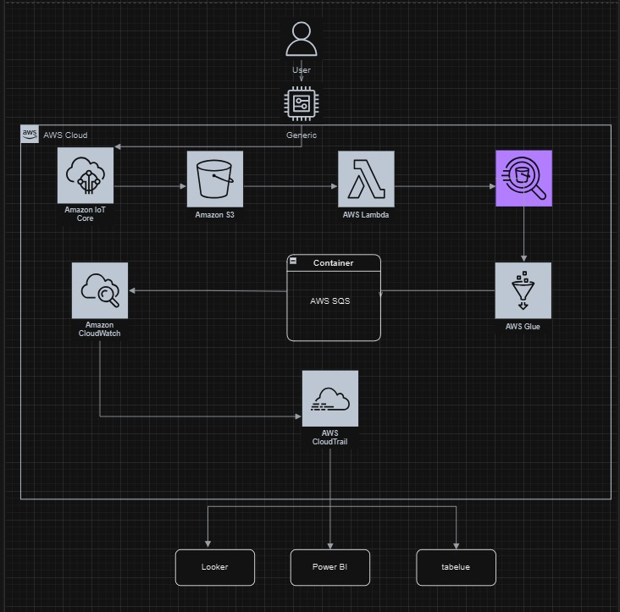

Connection of the S3 Bucket to AWS Lambda to S3 bucket:

Step 1: Prepare the S3 Bucket
- Connect your IoT Core to the S3 Bucket: Ensure that your IoT Core publishes data to your initial S3 bucket. This is the source bucket where IoT data will be stored.
- Make the Bucket Public:
  - Go to S3 in the AWS Console, select your source bucket, and adjust the Permissions to make it public.
  - Update the Bucket Policy as shown in later steps to ensure Lambda has the required access.
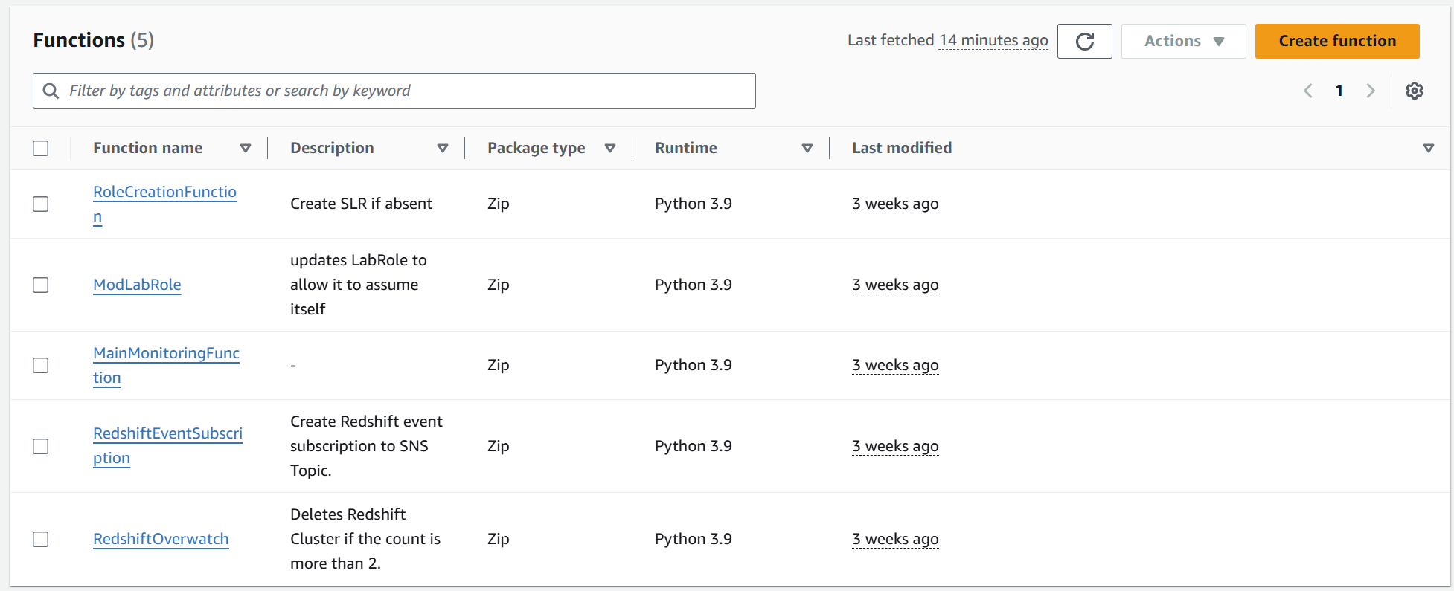

Step 2: Set Up a New Lambda Function
- Navigate to AWS Lambda:
  - Open AWS Lambda in the AWS Console.
  - In the left sidebar, select Functions.
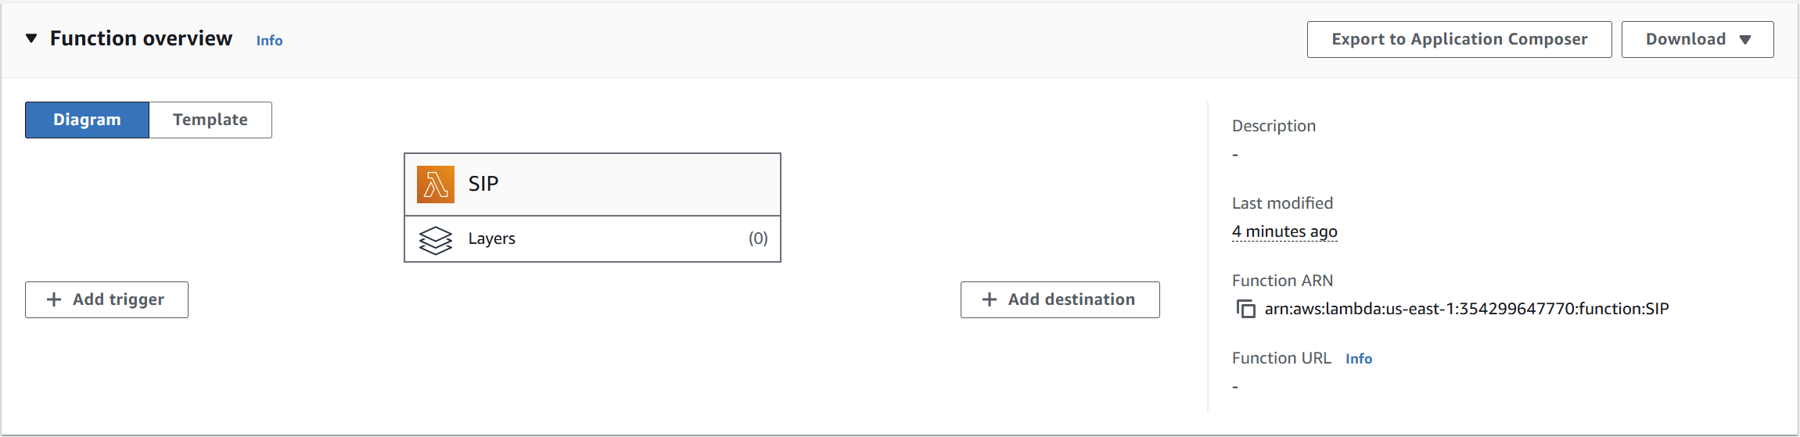
- Create the Function:
  - Click on Create function.
  - Choose Author from scratch.
  - In Function name, enter a name like "SIP" to identify your Lambda function.
  - Set the Runtime to Python 3.8 (or another compatible version with your libraries).
  - Choose x86_64 for Architecture unless you have specific reasons to use an ARM-based instance.
  - For Execution role, select Use an existing role and attach the role that grants necessary permissions for S3 access.
  - Click Create function.

Step 3: Add AWS SDK Layers for Data Handling in Lambda
To allow Lambda to process and manipulate data from S3, you need to add necessary layers:
- Go to the Layers Section:
  - In your Lambda function's configuration page, select Layers.
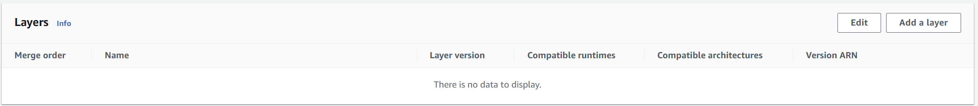
  - Click on Add a layer to configure layers.

- Add the First Layer – AWS SDK Pandas:
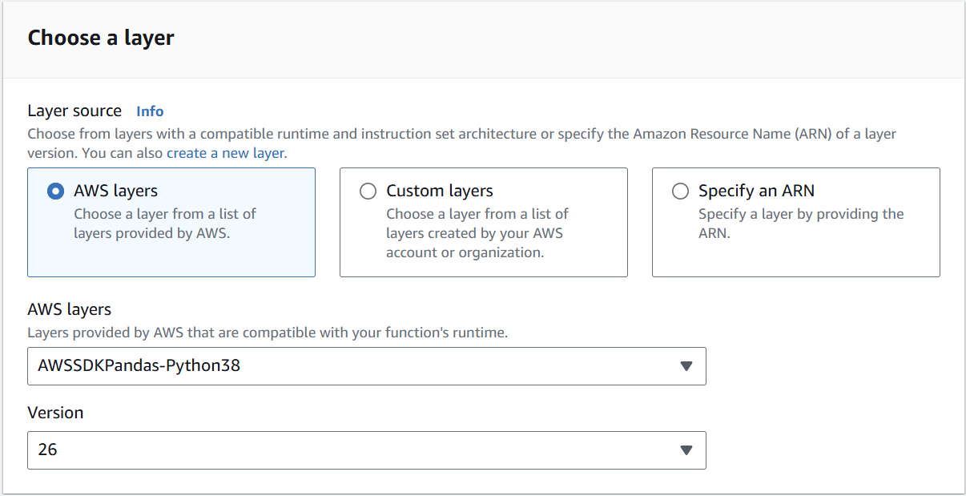
  - Select AWS layers from the available options.
  - From the list, choose AWSSDKPandas-Python38 and set Version to 26. This SDK provides tools to easily read from and write to S3.

- Add the Second Layer – AWS Wrangler:
  - To use AWS Wrangler, a data wrangling library, you first need to install it in Jupyter Notebook.
    - In Jupyter Notebook, run: pip install awswrangler.
    - After installation, locate the awswrangler files in Anaconda under lib/site-packages.
  - Zip the awswrangler package files for upload.
  - In Lambda, go back to Layers and create a new custom layer.
  - Name this layer and set the Runtime to Python 3.8.
  - Upload the zipped awswrangler package to this layer.

Step 4: Implement a Test Event to Simulate S3 Trigger
To test Lambda’s ability to receive events when new objects are uploaded to S3:
- Go to Code Source:
  - In the Lambda function's Code source section, select Test.
- Configure the Test Event:
  - Choose Configure test event and add the following JSON to simulate an S3 event:
json
Copy code
{
"Records": [
{
"eventVersion": "2.1",
"eventSource": "aws:s3",
"awsRegion": "us-east-1",
"eventTime": "2024-11-05T05:15:57.875Z",
"eventName": "ObjectCreated:Put",
"s3": {
"bucket": { "name": "tbucket0309" },
"object": { "key": "myKey", "size": 59 }
}
}
]
}
- Save and Deploy the Test:
  - Save this test configuration and deploy it to verify the function is triggered correctly when a new file is uploaded to the specified S3 bucket.

Step 5: Add Lambda Code to Handle S3 Bucket Data
This code enables your Lambda function to read from the source S3 bucket, process the data, and write to a destination S3 bucket.
- Add the Following Python Code to Lambda:
python
Copy code
import awswrangler as wr
import os
import logging
import boto3

logger = logging.getLogger()
logger.setLevel(logging.INFO)

s3_client = boto3.client('s3')

def lambda_handler(event, context):
logger.info("New files uploaded to the source bucket.")
logger.info(f"Event received: {event}")

try:
# Define file name and buckets
key = "iot_generated_data2.csv" # Update this to match the file name
source_bucket = "uiflowbucket" # Set the source bucket name
destination_bucket = os.environ['DESTINATION_BUCKET'] # Define destination bucket as an environment variable

source_path = f"s3://{source_bucket}/{key}"
destination_path = f"s3://{destination_bucket}/{key.replace('.csv', '_wrangled.csv')}"

# Check if the file exists
try:
s3_client.head_object(Bucket=source_bucket, Key=key)
logger.info(f"File found: {source_path}")
except s3_client.exceptions.NoSuchKey:
logger.error(f"No file found at path: {source_path}")
return {"errorMessage": f"No files found at: {source_path}.", "errorType": "NoFilesFound"}

# Read data from S3
data = wr.s3.read_csv(path=source_path)
logger.info(f"Data loaded. Shape: {data.shape}")
logger.info(f"Data preview:\n{data.head()}")

# Wrangle data
if data.empty:
logger.warning("DataFrame is empty.")
return {"errorMessage": "DataFrame is empty after loading CSV.", "errorType": "EmptyDataFrame"}
data = data.fillna("N/A")

# Write processed data to destination
wr.s3.to_csv(df=data, path=destination_path, index=False)
logger.info(f"File successfully written to {destination_path}")
return {"status": "success", "message": f"File written to {destination_path}"}

except Exception as error:
logger.error("Error in Lambda processing.")
raise error
- Save and Deploy the Code.

Step 6: Update S3 Bucket Policies and CORS
To ensure that Lambda has the necessary permissions to read and write to the S3 buckets:
- Modify the Bucket Policy for uiflowbucket:
  - Go to the Permissions tab of uiflowbucket and add the following policy:
json
Copy code
{
"Version": "2012-10-17",
"Statement": [
{
"Effect": "Allow",
"Principal": "*",
"Action": "s3:PutObject",
"Resource": "arn:aws:s3:::uiflowbucket/*",
"Condition": {
"Null": { "s3:x-amz-server-side-encryption-aws-kms-key-id": "true" }
}
},
{
"Effect": "Allow",
"Principal": "*",
"Action": "s3:GetObject",
"Resource": "arn:aws:s3:::uiflowbucket/*"
}
]
}
- Set up CORS Configuration:
  - Under Permissions in the CORS configuration, add:
json
Copy code
[
{
"AllowedHeaders": [ "Authorization" ],
"AllowedMethods": [ "GET" ],
"AllowedOrigins": [ "*" ],
"MaxAgeSeconds": 3000
}
]

Step 7: Test the Entire Workflow
- Trigger a Test Event: Upload a sample file (matching the specified name and format) to uiflowbucket and check that it is processed and moved to finalbucket311204 as specified in your Lambda function.

Things we tried but didn’t work:
for the connection we tried several different methods we tried using different bucket configurations such as using a private bucket, different policy codes for each bucket allowing the permission to the different groups.

A couple of codes we tried :
import awswrangler as wr
import json
import os
import logging
import boto3
import pandas as pd # Import pandas for DataFrame creation

logger = logging.getLogger()
logger.setLevel(logging.INFO)

s3_client = boto3.client('s3')

def lambda_handler(event, context):
logger.info("New files uploaded to the source bucket.")

key = event['Records'][0]['s3']['object']['key']
source_bucket = event['Records'][0]['s3']['bucket']['name']
destination_bucket = os.environ['destination_bucket']

logger.info(f"Source bucket: {source_bucket}")
logger.info(f"Source key: {key}")
logger.info(f"Destination bucket: {destination_bucket}")

source_path = f"s3://{source_bucket}/{key}"
destination_path = f"s3://{destination_bucket}/{key}"

try:
# Step 1: Download the JSON file and load it into a Python dictionary
logger.info(f"Reading data from {source_path}")
s3_object = s3_client.get_object(Bucket=source_bucket, Key=key)
raw_data = s3_object['Body'].read().decode('utf-8')
json_data = json.loads(raw_data)

# Step 2: Check if JSON data is a list or single object
if isinstance(json_data, list):
logger.info("Converting JSON list to DataFrame")
data = pd.DataFrame(json_data) # Use pd.DataFrame for list
else:
logger.info("Wrapping single JSON object in list to convert to DataFrame")
data = pd.DataFrame([json_data]) # Wrap single object in list to make a DataFrame

# Step 3: Write the DataFrame to the destination bucket as JSON
logger.info(f"Writing processed data to {destination_path}")
wr.s3.to_json(df=data, path=destination_path, orient="records")

logger.info(f"File successfully written to {destination_path}")

except Exception as error:
logger.error("Error processing or writing the file.")
logger.error(f"Error Message: {error}")
raise error

import awswrangler as wr
import pandas as pd

def lambda_handler(event, context):
# Step 1: Parse the S3 event to get the source bucket and key
source_bucket = event['Records'][0]['s3']['bucket']['name']
source_key = event['Records'][0]['s3']['object']['key']

# Specify the second bucket to store the results
target_bucket = "bucket3112-final" # Replace with your second bucket name
target_key = f"processed/{source_key.split('/')[-1]}" # Use only the filename to avoid path duplication

try:
# Step 2: Read data from the first bucket using awswrangler
file_path = f"s3://{source_bucket}/{source_key}"
print(f"Reading data from {file_path}")
data = wr.s3.read_json(path=file_path) # Ensure the source data is in JSON format

# Step 3: Process data if needed (e.g., transform, filter, aggregate)
# For demonstration, we will convert it to a DataFrame if it isn't one already
if not isinstance(data, pd.DataFrame):
data = pd.DataFrame(data) # Convert to DataFrame if necessary

processed_data = data # Here you could add any processing logic

# Step 4: Write processed data to the second bucket
target_path = f"s3://{target_bucket}/{target_key}"
print(f"Writing processed data to {target_path}")
wr.s3.to_json(df=processed_data, path=target_path, index=False) # Ensure the correct format

print(f"Successfully wrote data to {target_bucket}/{target_key}")

except Exception as e:
print(f"Error processing file {source_key} from bucket {source_bucket}. Error: {str(e)}")
raise e

In our process of establishing an effective connection between AWS Lambda and the S3 bucket, we experimented with several approaches. Each approach faced challenges, primarily due to restricted configurations and access constraints. Here’s an outline of our efforts and their respective outcomes:
- Different Bucket Configurations:
  - We initially experimented with bucket settings, including private and public configurations, to verify that the Lambda function could read from and write to both source and destination buckets. We tried several policy adjustments to allow cross-account permissions and accommodate multiple access levels.
  - Outcome: This approach did not work as expected, as the IAM role policies were too restrictive for the Lambda function to gain access. Attempting to adjust these further was not feasible due to account-level limitations.
- Policy Code Adjustments:
  - We modified bucket policy codes to include broader permissions for specific actions like s3:PutObject, s3:GetObject, and s3:ListBucket. This was intended to create permissions for both public and private access for different user groups, but restrictions on IAM roles and budget constraints prevented further changes.
  - Outcome: Although some permissions were successfully added, the adjustments did not allow the function to run consistently as intended, and certain group permissions could not be applied across all actions needed.
- Code Approaches and Transformations Tried:
  - Several code variations were attempted, each aimed at handling JSON data through the Lambda function and saving it in the second S3 bucket. For instance, we tried:
    - First Code Block: This code loads JSON data from an S3 object into a Python dictionary, processes it, and saves it back to the destination bucket. It also checks whether the data is a single JSON object or a list and then writes it as JSON using awswrangler.
    - Second Code Block: In this version, the function reads JSON data from the source S3 bucket, processes it into a DataFrame if necessary, and writes it to the target bucket in JSON format.
  - Outcome: These codes didn’t execute as expected, primarily due to the inability to accurately configure all necessary permissions. Budget limitations and restrictions on adjusting key IAM roles further hindered these attempts.

